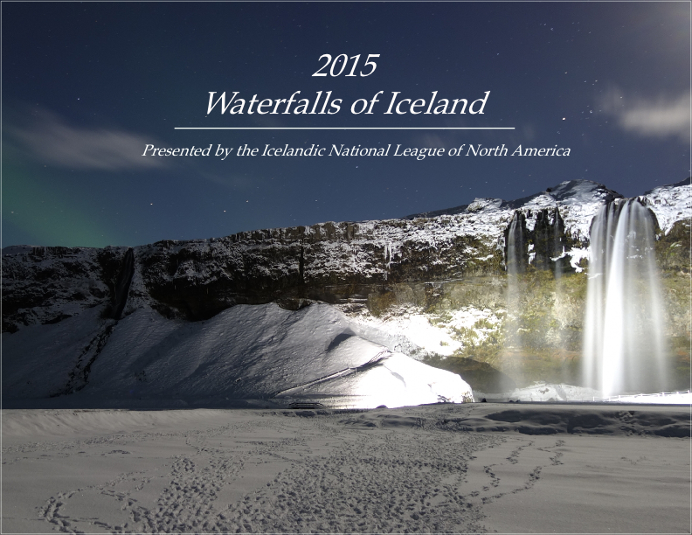

**2015 INL Calendar Order Form**

**Icelandic Waterfalls Photography by INL of NA members**

**Save time and postage.** Order calendars by email and arrange for delivery or pick up at an ICCT event! **Email:** [**treasurer@icct.info**](mailto:treasurer@icct.info) Pick one up at the AGM Tues. Sept. 15 or the Nordic Nights Movie Tues. Oct. 21

**To pay by PayPal click the DONATE button:** [**www.icct.info**](http://www.icct.info)**.** Don’t forget to include a message that the money is for the purchase of calendars.

To order by mail,please fill out the form below and include a cheque made payable to: *Icelandic Canadian Club of Toronto.*

Lynne Thorkelsson, Treasurer ICCT,1680 Scugog Street, Port Perry ON, L9L 1E2

**Order:** QTY#_______ X $12.00 = TOTAL $___________**___**

**Shipping 2014 Calendars by mail:**

1st calendar plus shipping $12 + $2= $14

(Shipping more calendars $1 each)

More calendars $12 +$1 x _____ = ______

Total cheque enclosed $______

**Name:______________________________________________________________**

**Phone**:________________________________________

**Mailing Address:**

______________________________________________________________________

**Postal Code**: __________________

**OR - Apply your address label here.**